Table 5: Bite Marks
Bite Marks Found at Crime Scene | Suspect Bite Marks
001G | 002F
002G | 012F
003G | No Match

Crime Scene Bite Mark | Suspect Bite Mark
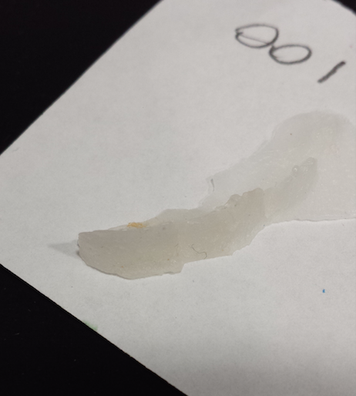 | 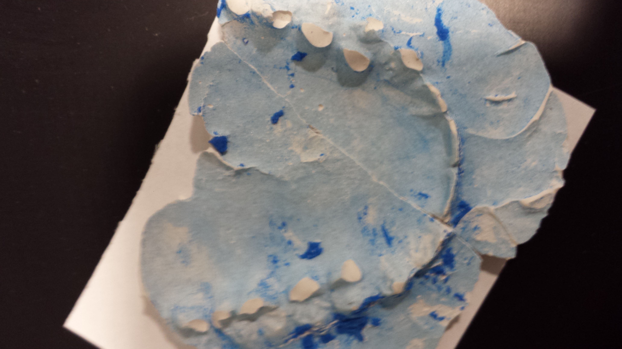
Figure 20 (Photo taken by Brandon Llewellyn) shows a wax mold of a bite mark that was found at the scene of a crime. Figure 21 (Photo taken by Brandon Llewellyn) shows a plaster mold of a suspect’s teeth.
17

It was very difficult for the students to find specific features on the wax molds. To come to this conclusion, the students sized the wax mold up to the plaster mold and found that each tooth was the same size as their counterparts. The students did not have high confidence in their conclusion. There was not enough confidence in the matches to make claims against the suspect, saying that they were at the scene of the crime, in court.
Crime Scene Bite Mark | Suspect Bite Mark
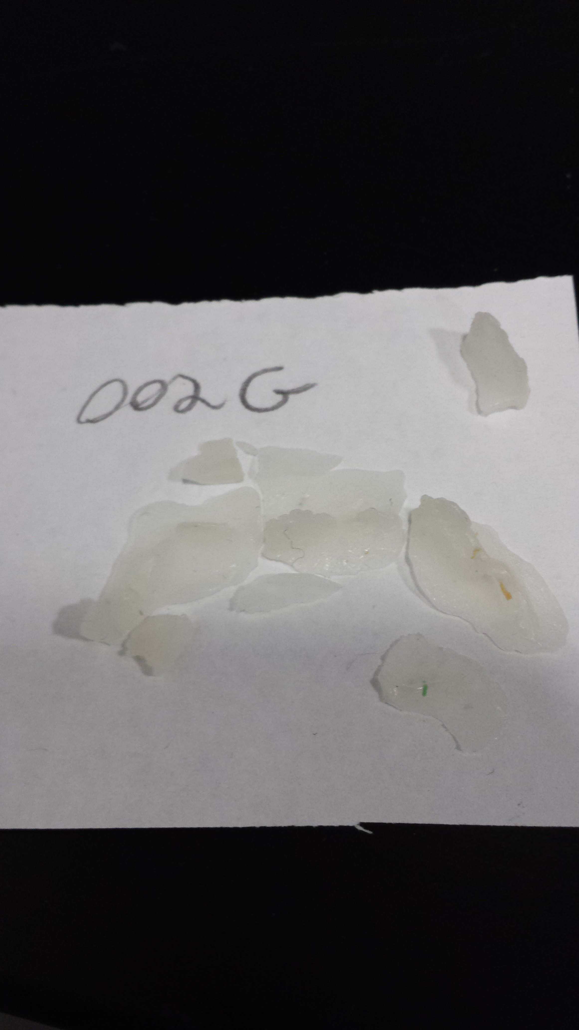 | 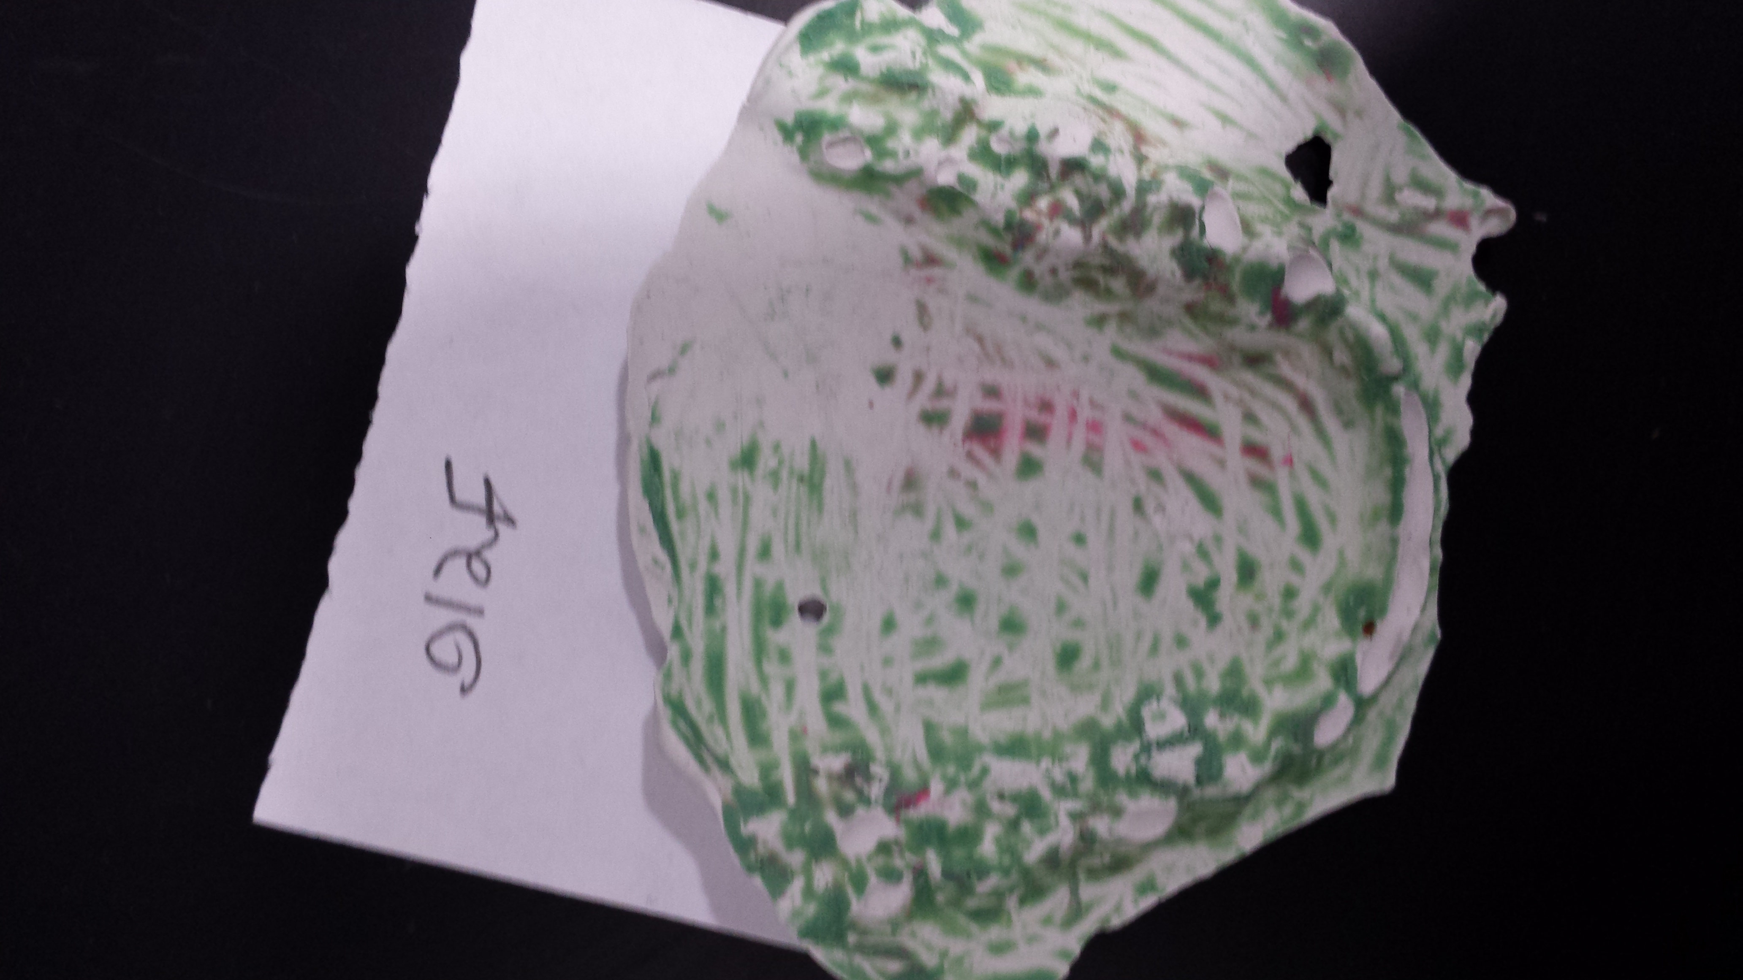
Figure 22 (Photo taken by Brandon Llewellyn) shows a wax mold of a bite mark that was found at the scene of a crime. Figure 23 (Photo taken by Brandon Llewellyn) shows a plaster mold of a suspect’s teeth.
18

It was very difficult for the students to find specific features on the wax molds. To come to this conclusion, the students sized the wax mold up to the plaster mold and found that each tooth was the same size as their counterparts on the plaster mold. The students did not have high confidence in their conclusion. There was not enough confidence in the matches to make claims against the suspect, saying that they were at the scene of the crime, in court.
Crime Scene Bite Mark | Suspect Bite Mark
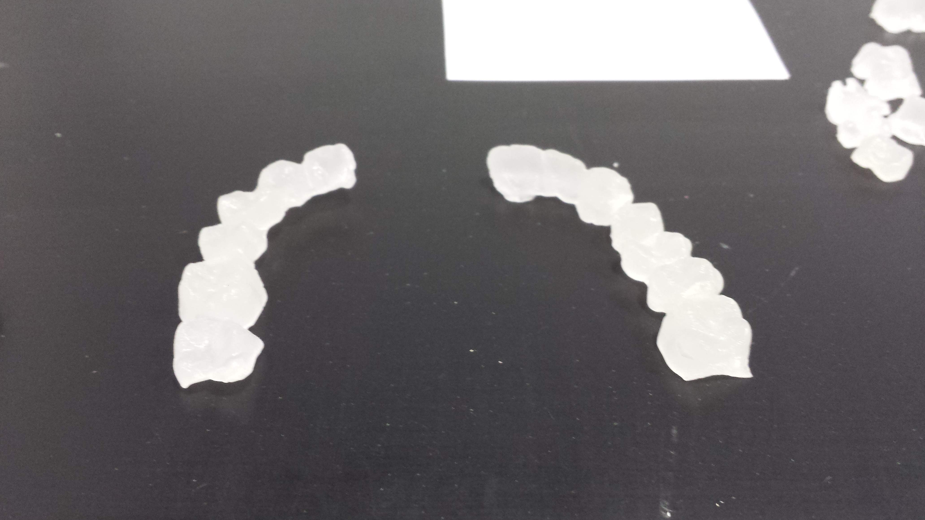 | No Match
Figure 24 (Photo taken by Brandon Llewellyn) shows a wax mold of a bite mark that was found at the scene of a crime.
19
The students did not find a match to this set of wax teeth. These wax teeth were unique in the fact that they had little pieces that protruded off of the bottom right bicuspid, bottom right cuspid, bottom left cuspid, bottom left bicuspid, top first molar on both sides, top two bicuspids on both sides, top left cuspid, and top left lateral incisor. These traits were not found on any of the suspect molds. The students determined that the person who left the bite marks was not a suspect and thus was not in custody.
Discussion
It is important to note that someone cannot be solely convicted of a crime just because his or her fingerprints or bite mark was found at the scene of a crime. The person could have been to the place before the crime occurred, touched something, and left their fingerprints behind. Also, a person could have bitten an apple and tossed it out at a crime scene before the crime was even committed. If the bite marks were found on human flesh however, they would be more likely to be convicted because of the strong evidence against them. Additional evidence is often key in these cases.
It was found that many techniques for analyzing fingerprints and bite marks exist. The students in the lab used the techniques to determine who committed what crimes in the city of Battle Creek. The students learned that not all of the techniques work. For example, the ninhydren technique was a total failure because they could not see them enough to be able to find common traits with prints from the suspects. The only advantage to this technique was that it was very fast and simple. Aluminum dusting was also hard to read because the aluminum powder tended to bunch up and filling in holes. Also, the aluminum powder was very dense, and a little went a long way in terms of how much powder to have on a brush. Super Glue® fuming resulted in some very nice prints, however they could only be seen if the glass fragments they were on were held at the perfect angle in the perfect light. The other downside of using the Super Glue® fuming technique was that it could only be used on small objects that could be easily moved. Carbon dusting had the best results out of all of the fingerprints and was relatively easy to do. One downside of using dusting techniques was that it was very hard to dust on vertical surfaces because the powder would fall down to the ground and not much would be left on the print. Analyzing bite marks was extremely hard because the wax molds taken from the crime scene were incomplete and very few had whole teeth molded. The plaster molds were a step up from the wax, but it was still hard to locate key features on them. A huge problem during the lab was that the wax and plaster molds kept falling apart. This caused some molds to be incomplete which made it even harder to find matching wax and plaster molds.
20
Both the bite mark molds and the fingerprints had to be handled with care. If someone pushed down too hard on a fingerprint with a brush, the print might have become smeared and would have been rendered useless. Also, if someone dropped a wax bite mark mold, it could have shattered into lots of tiny pieces. The pieces could be unsalvageable and the bite mark would be gone. Bad technique when analyzing the fingerprints and bite marks could have resulted in false accusations. This would lead the authorities to arrest an innocent person and would set the real culprit free. These mistakes can mean the difference between putting away a criminal and putting an innocent man in jail and letting the perpetrator roam free.
21
Bite mark and fingerprint analysis are important factors in the criminal justice system; they are pieces of a person’s identity that can be used to find people who possibly committed the crime. Both the bite marks and the fingerprints have to be handled with care so that they do not get damaged. This is very important because once the evidence is gone, it is gone forever. When all is said and done, more evidence typically must be presented in order to convict someone. More evidence is needed because errors could have been made along the way could have given false results. This could have lead to the convictions of innocent people.

22

