Local Crime Spree Suspect Identification Through The Use of Latent
Fingerprints & Bite Marks
Katie Nickolaou
Forensic Science 4A
Mr. Muhich
November 7th, 2014

Table of Contents
Abstract 3
Introduction 3
Methods 5
Results 7
Discussion 21

Abstract
The Battle Creek Police Department was flooded with evidence
from a recent crime spree and outsourced some of the evidence toq
the BCAMSC Crime Lab. The evidence consisted of fingerprints
and bite marks. The students in the lab used multiple techniques to
analyze the fingerprints and bite marks. They matched
fingerprints/bite marks taken from crime scenes and compared
them to the fingerprints/bite marks they obtained from the suspects.
They drew conclusions on some of the prints and were unable to
find matches for the others. The same was true for the bite marks.
In the end the students agreed that more evidence needed to be
gathered and that different types of evidence also needed to be
gathered in order to prevent convicting innocent people due to
possible errors in their analyses.
Introduction
Forensics is, simply put, the application of science to law. Forensics is a vast field of science that has many small parts within it. Two of these parts are odontology, the study of teeth, and latent print identification, the study and analysis of fingerprints. In each of these fields, evidence is key, and retrieving it can pose a challenge. Evidence is any physical object that proves a crime was committed and/or is something that can link a perpetrator to a crime. There is also control evidence, which is used to compare items from a suspect (a control) to what was found at the crime scene. In order to get a control from a suspect, a warrant must be obtained, unless the person gives their consent, it is an emergency situation, if it is within the immediate control of the person if it is after a lawful control, it is at a border crossing, or if the evidence will soon be lost. The evidence will then be used to reconstruct the crime scene and will be used to identify the culprit. There are two types of evidence: class and individual. Class evidence links a group of people to a crime scene while individual evidence links a single person to a crime scene. Both fingerprints and bite marks are individual evidence.
Everyone’s bite marks and fingerprints are unique and on of a kind. There are three typical fingerprint patterns: arches, loops, and whorls. Fingerprints can also contain any number/combination of bifurcations, short ridges, islands, ridge endings, ridge crossings, and enclosures. In order to say that two prints match each other, they must have 8-16 points in common. Fingerprints are similar to bite marks because they are also unique to individuals, unless a person has dentures. It is easier to match teeth to people because of dental records, while not many people have their fingerprints on file.
The students at the Battle Creek Area Math and Science Center Crime Lab became quite familiar with these techniques recently. They also learned how to analyze and compare both fingerprints and bite marks.
After a recent crime spree, the Battle Creek Police Department was overrun with fingerprint and bite mark analyses and decided to outsource to the BCAMSC Crime Lab. The lab received multiple fingerprint and bite mark molds taken from crime scenes. They were asked to analyze the fingerprints/bite marks and to attempt to find a match from a list of suspect fingerprints/bite marks.

Methods
One day the Battle Creek Police Department was overrun with fingerprint and bite mark analyses and decided to outsource to the BCAMSC Crime Lab. he lab received three ninhydren fingerprints, three aluminum dusting fingerprints, four carbon dusting fingerprints, four Super Glue® fingerprints, and three bite mark molds taken from crime scenes. They also received a set of fingerprints (both left hand and right hand) for each of the thirteen suspects.
The process for recovering bite marks and fingerprints is a tedious one. To recover fingerprints, multiple methods can be used, including using aluminum dusting, carbon dusting, Super Glue® fuming, and using ninhydren. Aluminum dusting is primarily used when one has to collect fingerprints off of a dark, nonporous surface, such ask a chalkboard or three-hole punch. To apply the aluminum dust, one must use a very fine brush. They must dip the dust in the aluminum dust, shake of the excess powder, and then spin the brush gently across the print. In order to not damage the print, be sure not to push down too hard on the print with the brush. They must then blow off the extra dust. Next they have to take a strip of tape, press it down carefully on the print, get rid of all air bubbles, lift the tape up carefully, and place the tape on a sheet of black paper. Carbon dusting has the same procedure as the aluminum, only it is used on light colored surfaces and glass and it uses carbon dust instead of aluminum dust. Super Glue® fuming is used on small, nonporous pieces of evidence, such as a small piece of broken glass. In order to do a Super Glue® fuming, they must place the object in a sealed chamber and must expose it to Super Glue® fumes. The Super Glue® has cyanoacrylate in it that crystalizes on the fingerprints, thus making them visible. Ninhydren is used on porous surfaces, such as a piece of paper. The only thing that must be done is that the ninhydren must be sprayed onto the porous surface and it must be left to dry. Once it is dry, the prints will start to develop and a fingerprint will become visible. It is important to note that when the ninhydren reacts with the amino acids in the print, the reaction causes the print to turn purple. As for bite marks, they can be taken from any surface that can hold a print. In this case, the bite mark was in an apple. The team recovered the bite mark by melting down wax and dropping individual little wax drops into the apple. Once the wax cooled, the pieces of apple were removed, and the wax cast of the teeth was left.
Evidence was then collected from the suspects. Each suspect was instructed to roll one finger on an inkpad and then to roll that finger into the appropriate area on a modus operandi sheet. Their basic information was also recorded on the modus operandi sheet. This was repeated for every finger on each hand. To obtain bite mark molds from the suspects, the suspects had to bite into a ball of clay that was wrapped in a plastic bag. The bag was carefully taken off and the clay was then taken over to a station where plaster had been mixed. The students poured the plaster into the clay. Once the plaster dried, the clay was removed and the suspect’s bite mark was obtained.
Once the prints arrived at the Center, the students divided up the prints based on what type of fingerprinting technique was used to obtain them. The students in the lab then took each individual fingerprint and, with the help of a magnifying glass, located any special features on them. Such special features include bifurcations, when a line slits into two parts/branches, enclosures, when a little circle is in the middle of a line, ridge crossings, when two lines cross over each other, islands, small dots located between lines or within enclosures, short ridges, small lines that form between lines or within enclosures, and ridge endings, where lines suddenly end. The students then looked through the suspect prints in order to find a match. To classify a fingerprint as a match, the suspect print and the print at the crime scene must have 8-16 special features in common. Once a student finds what they believe to be a match, the write down the serial number on the back of the crime scene print as well as the serial number and the finger of the matching suspect print. This was done fore each of the fingerprints until there were none left. It is important to know that not all of the fingerprints had matching suspect prints. This means that the person who committed the crime is still loose, which is a very bad thing. The students also divided up the three bite marks. They placed the plaster molds next to them so they could compare them to the bite marks found at the crime scene.

Results
The students studied the fingerprints and the bite marks and drew some conclusions. They recorded their findings in the following tables. To support their claims, the student circled any bifurcations, short ridges, islands, ridge endings, ridge crossings, and enclosures. Each colored circle on the crime scene prints match with the circle of the same color on the suspect prints. Note that the circles were not drawn on the actual prints, but were instead added onto pictures of the prints.

Table 1: Carbon Dusting
Crime Scene Print | Suspect Print
001D | 004A 1st Finger Right Hand
002D | 013A Thumb Right Hand
003D | 001A Thumb Left Hand
004D | 005A Right Thumb

Crime Scene Print  Serial Number 001D | Suspect Print  Serial Number 004A  1st Finger Right Hand
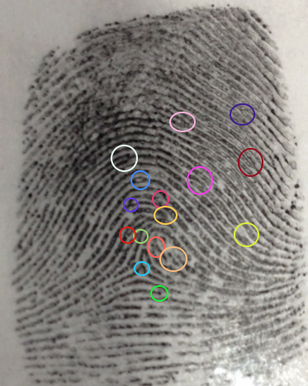 | 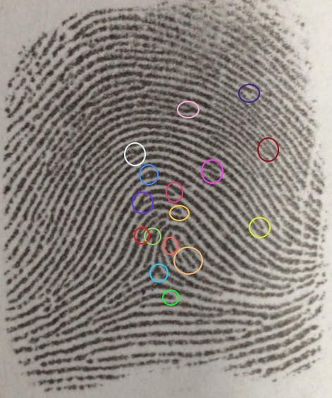
Figure 1 is a carbon-dusted fingerprint from a crime scene. Figure 2 shows a suspect’s control print. In both pictures the common points that the share are highlighted.

Because they found sixteen different common points between the fingerprints, the students concluded that the suspect with serial number 004A was indeed at the crime scene. Theses prints could be used against the suspect in court.

Crime Scene Print  Serial Number 002D | Suspect Print  Serial Number 013A  Thumb Right Hand
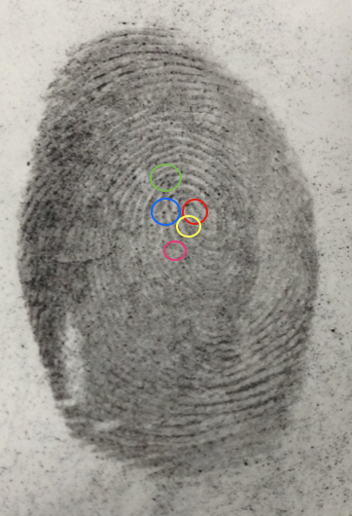 | 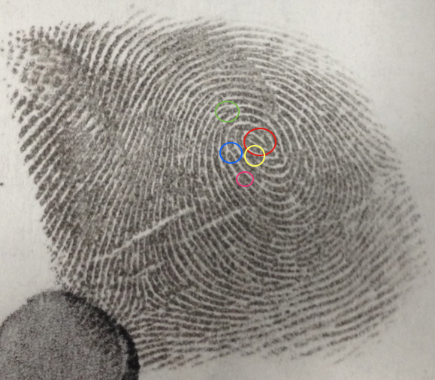
Figure 3 is a carbon-dusted fingerprint from a crime scene. Figure 4 shows a suspect’s control print. In both pictures the common points that the share are highlighted.

The group could only identify five points in common between the two prints. Because of this, there was not enough confidence in the matches to make claims against the suspect in court.

Crime Scene Print  Serial Number 003D | Suspect Print  Serial Number 001A  Thumb Left Hand
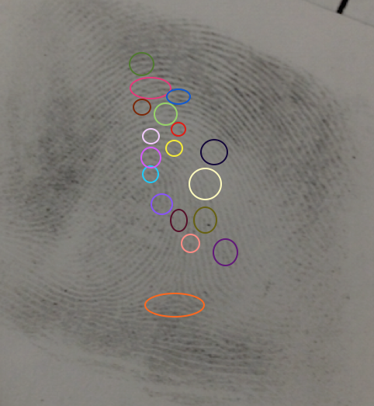 | 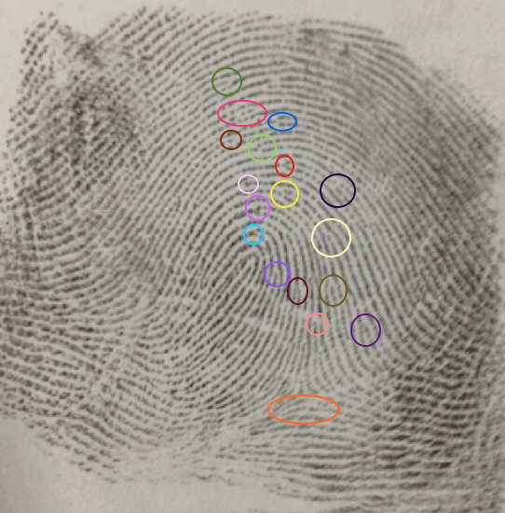
Figure 5 is a carbon-dusted fingerprint from a crime scene. Figure 6 shows a suspect’s control print. In both pictures the common points that the share are highlighted.

Because they found sixteen different common points between the fingerprints, the students concluded that the suspect with serial number 001A was indeed at the crime scene. Theses prints could be used against the suspect in court.
Crime Scene Print  Serial Number 004D | Suspect Print  Serial Number 005A  Thumb Right Hand
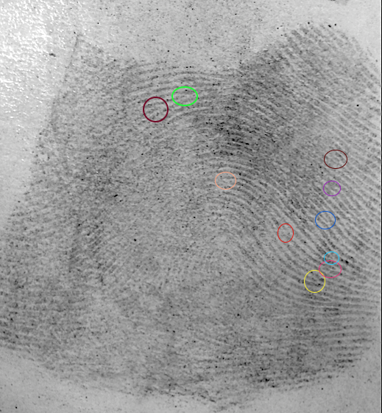 | 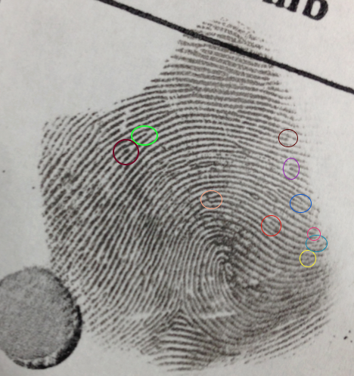
Figure 7 is a carbon-dusted fingerprint from a crime scene. Figure 8 shows a suspect’s control print. In both pictures the common points that the share are highlighted.

Because they found ten different common points between the fingerprints, the students concluded that the suspect with serial number 005A was indeed at the crime scene. Theses prints could be used against the suspect in court.

Table 2: Aluminum Dusting
Crime Scene Print | Suspect Print
001C | No Match
002C | No Match
003C | 008A Right Thumb

Crime Scene Print  Serial Number 001C | Suspect Print
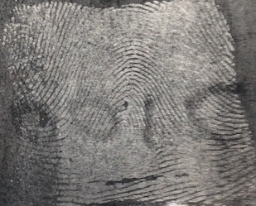 | No Match
Figure 9 is an aluminum-dusted fingerprint from a crime scene.

The group could not identify any points in common between the print at the crime scene and any of the suspect prints. The crime scene print was too faint to read. Because of this, there was not enough confidence in the match to make claims against the suspect, saying that they were at the scene of the crime, in court.

