Crime Scene Print  Serial Number 002C | Suspect Print
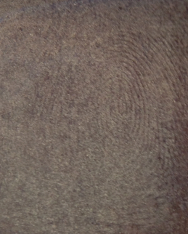 | No Match
Figure 10 is an aluminum-dusted fingerprint from a crime scene.

The group could not identify any points in common between any of the suspect prints and the crime scene print. The crime scene print was too faint to read. Because of this, there was not enough confidence in the match to make claims against the suspect, saying that they were at the scene of the crime, in court.

12
Crime Scene Print  Serial Number 003C | Suspect Print  Serial Number 008A  Thumb Right Hand
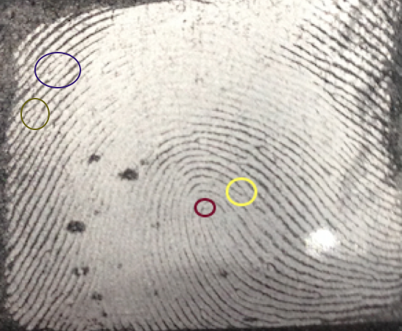 | 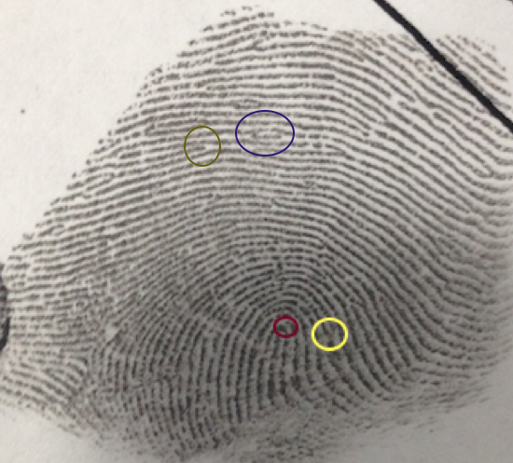
Figure 11 is an aluminum-dusted fingerprint from a crime scene. Figure 12 shows a suspect’s control print. In both pictures the common points that the share are highlighted.

Because the group could only identify four points in common between the two prints, they were not confident in their conclusion. Since there was not enough confidence in the match to make claims against the suspect, saying that they were at the scene of the crime, in court.

Table 3: Ninhydren
Crime Scene Print | Suspect Print
001B | No Match
002B | No Match
003B | No Match
All three of the ninhydren prints were too light to see any kind of patterns on them. They were so light that the students could not take accurate pictures of them. It was because of this that the ninhydren prints couldn’t be used to bind any of the suspects to any of the three crime scenes.
13

Table 4: Super Glue® Fuming
Crime Scene Prints | Suspect Prints
001E | No Match
002E | 001A Right Hand First Finger
003E | 003A Left Hand Thumb
004E | 004A Right Hand Thumb

Crime Scene Print  Serial Number 001E | Suspect Print
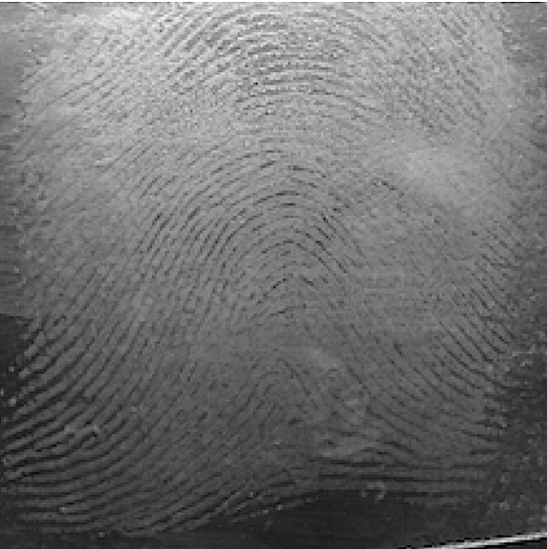 | No Match
Figure 13 shows a Super Glue® fumed fingerprint that was taken from a crime scene.

The group could not identify any points in common between any of the suspect prints and the crime scene print. The crime scene print was too faint to read. Because of this, there was not enough confidence in the match to make claims against the suspect, saying that they were at the scene of the crime, in court.
14

Crime Scene Print  Serial Number 002E | Suspect Print  Serial Number 001A  First Finger Right Hand
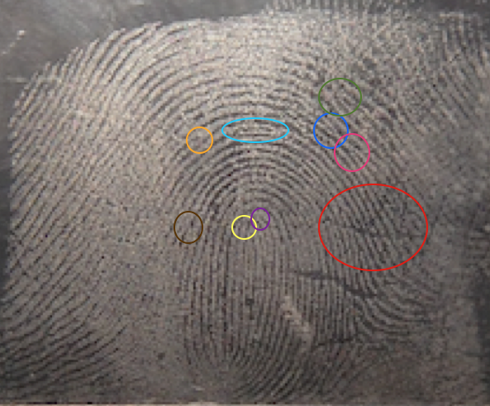 | 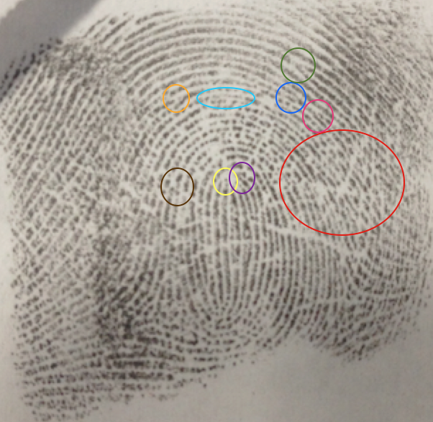
Figure 14 is a Super Glue® fumed fingerprint that was taken from a crime scene. Figure 15 shows a suspect’s control print. In both pictures the common points that the share are highlighted.

Because they found nine different common points on the fingerprints, the students concluded that the suspect with serial number 001A was indeed at the crime scene. Theses prints could be used against the suspect in court.

15
Crime Scene Print  Serial Number 003E | Suspect Print  Serial Number 003A  Thumb Left Hand
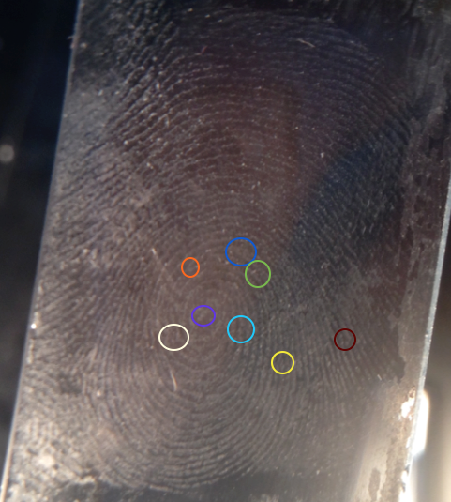 | 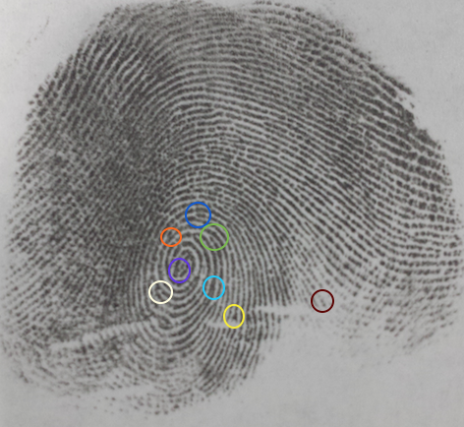
Figure 16 is a Super Glue® fumed fingerprint that was taken from a crime scene. Figure 17 (Photo taken by Brandon Llewellyn) shows a suspect’s control print. In both pictures the common points that the share are highlighted.

Because they found eight different common points on the fingerprints, the students concluded that the suspect with serial number 003A was indeed at the crime scene. Theses prints could be used against the suspect in court.

16

Crime Scene Print  Serial Number 004E | Suspect Print  Serial Number 004A  Thumb Right Hand
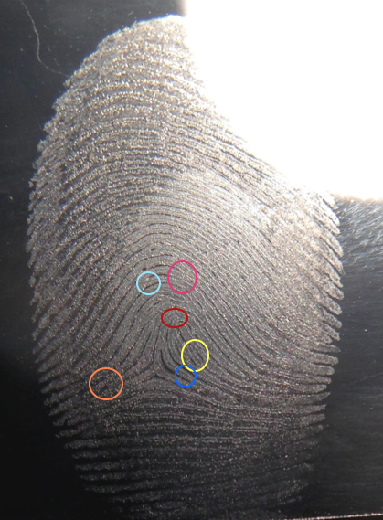 | 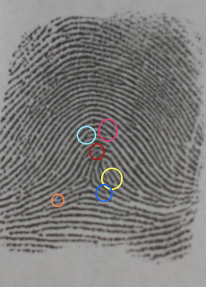
Figure 18 is a Super Glue® fumed fingerprint that was taken from a crime scene. Figure 19 shows a suspect’s control print. In both pictures the common points that the share are highlighted.

Because the group could only identify six points in common between the fingerprints, they were not confident in their conclusion. There was not enough confidence in the matches to make claims against the suspect, saying that they were at the scene of the crime, in court.
17

